Super Irshad! Attendance system-oda intha "List + Dictionary + Loop + If" logic thaan unga software-oda adippadai (foundation). Ippo namma Lesson 27: Inheritance-kku enter aagalaam!
Kuzhandhaikku solra maari, ithaiyum simple-a pakalam.
📖 Lesson 27: Inheritance (Adhu yen Super Power?)
Inheritance-na "Appa-kitta irundhu kidaikkura swapthiram" maari. Oru Class (Appa) irukku na, adha extend panni innonru Class (Magal/Magan) create panna mudiyum.
🛠️ Example Code: Employee Attendance
Namma Attendance system-laye oru "Manager"-ai add pannuvom.
Python
# Appa Class (Parent)
class Employee:
def __init__(self, name):
self.name = name

def display(self):
print(f"Employee Name: {self.name}")

# Magan Class (Child) - Employee-a inherit pannudhu
class Manager(Employee):
def give_permission(self):
print(f"{self.name} is giving permission.")

# Execution
m = Manager("Irshad")
m.display() # Appa class-oda property
m.give_permission() # Sontha property
🔍 Kuzhandhai-kku Vilakkam:
- Employee Class: Ithu oru "Samaanya Employee"-oda template. Name irukkum, display panna mudiyum.
- Manager Class: Manager-um oru Employee dhaan (Name irukkum, display panna mudiyum). So, namma thirumba name irukkuma, display irukkuma nu kavalai pada vendiya avasiyam illa.
- Inheritance (class Manager(Employee)): "Manager-um oru Employee dhaan, so appa-kitta irukkura ellathaiyum kuduthudu" nu namma solrom. Idhu dhan Inheritance.
💡 Teacher's Note:
Neenga oru periya HR System build panna, ellaa employee-kum name, id, salary nu common-a irukkum. Inheritance use panna, neenga code-ai thirumba thirumba ezhutha vendiya avasiyam illa. Oru murai ezhuthina pothum!
Ippo intha inheritance concept purinjidha Irshad? Ithu purinjidha, namma adutha stage-ana Encapsulation (Data Protection)-kku pogalaam—adhu dhaan unga data-vai yaarum thiruda mudiyatha alavukku lock panra method!
Irshad, kavalai padaatheyenga! Code-ai oru mandhiram maari paarkkaama, "Oru velaiyai eppadi seiya" nu solli kodukkura "Instruction Card" maari paarkkalam.
Namma "Inheritance" kodutha example-ai line by line-a pirichu, "Sign by Sign" (kuriyeedu) vilakkuren:
Code Breakdown:
Python
class Employee: # 1. 'class' na oru blueprint (Design). 'Employee' nu peru vachirukkom.
def __init__(self, name): # 2. 'def' na oru velai (Function). '__init__' na, pusaala vandhu munnadiye set panra 'Setup' velai.
self.name = name # 3. 'self.name' na, intha card-kulla 'name'-ai store panni vechukkoda nu artham.

def display(self): # 4. Innonru 'def' velai. 'display' na veliya kaatradhu.
print(f"Name: {self.name}") # 5. 'print' na screen-la kattu.

class Manager(Employee): # 6. 'Manager' nu pudhu blueprint. Bracket-kulla 'Employee' irukka?
# Athu dhaan 'Inheritance' (Appa-kitta irundhu kidaikkurathu).
def give_permission(self): # 7. 'Manager'-kku nu sonthama oru velai.
print(f"{self.name} is giving permission.") # 8. Manager-oda sontha velai.

m = Manager("Irshad") # 9. 'm' nu oru manager-ai create panrom. Avar peru 'Irshad'.
m.display() # 10. Avar 'Employee' nu blueprint-la irundha velaiyai seiyararu.
m.give_permission() # 11. Manager-oda sontha velaiyai seiyararu.
Sign by Sign Vilakkam:
- class: Ithu oru "Satchu" (Template). Inga namma Blueprint create panrom.
- def: Ithu oru "Velai" (Action). Enna seiyanum nu solrom.
- __init__: Ithu "Start" pannum pothu seiya vendiya setup. (Yarai create panromo, avara munnadiye fill panni vechukkum).
- self: Ithu "Naane" nu artham. "Ennakku vendiya name-ai naane store panikiren" nu computer-kku solrom.
- () (Brackets): Ithu oru "Koodai" maari. Data-vai ullai kondu varathukku payanpaduthuvom.
- : (Colon): Ithu "Adutha Variyai paaru" nu solla. Indha symbol-kku appuram varura ella lines-um indha 'class' illana 'def'-kku kizhappa seiyappadum.
- Manager(Employee): Intha Bracket-kulla irukkura Employee dhaan "Inheritance" symbol. "Manager-a, Employee-oda ellathaiyum kuduthudu" nu solrom.
Teacher's Note:
Purinjidha Irshad? Namma Class-ai blueprint-a create panrom, def-a velaiya seiyarom, bracket-a data-vai anupparom.
Ithu kooda confuse-a irukka, illana innum simplified-a sollava? Unga kitta irukkura HR System-laiye intha logic-ai eppadi podalam nu sollaavaa?
Ippaum suthama velangailla edu edoda link aagudu edu enda vela saidu edu munnadi vela siaidu ondume velanguduilla teacher enn awsaram idula theriyama eppadi munuku poradu suthhama velangudilla word by wordah sign by sign thliwa kulaindaikki pola solli thanga
Irshad, kovam varuvathu migavum saadharanam. Naan thappu panniten, innum romba simple-a, unga kaila oru pencil-ai vachukittu "ithu ithu" nu kattura maari solren.
Konjam porumaiya intha "Manager"-ai oru "Employee"-oda thodarbaaga paarkkalam.
1. Blueprint (Class) - Ithu oru "Template"
Oru katti kattu munnaadi oru design paper vachupom la? Athaan class.
Python
class Employee: # [Sign 1] 'class' na, "Pudhu blueprint design panren" nu artham.
# [Sign 2] 'Employee' na, intha blueprint-ku vaikkura peru.
def __init__(self, name): # [Sign 3] 'def' na, "Oru velai" (Function).
# [Sign 4] '__init__' na, "Blueprint-ai vachukittu munnadiye seiya vendiya setup".
# [Sign 5] 'name' na, antha employee-oda peyar.
self.name = name # [Sign 6] 'self' na "Naane". "Intha blueprint-la 'name'-ai store panni vachukuren".
2. Inheritance (Appa-kitta irundhu kidaikkurathu)
Ippo oru Manager-ku, oru Employee-oda ella powers-um venum.
Python
class Manager(Employee): # [Sign 7] Bracket-kulla 'Employee' irukku.
# Ithu dhaan 'Inheritance'.
# "Manager-ku Employee-oda ella design powers-um kuduthudu" nu artham.
3. Eppo Enna Nadakkudhu? (Step by Step)
- m = Manager("Irshad"):
  - Inga thaan velai start aagudhu.
  - Naan oru Manager-ai create panren, avaroda peyar "Irshad".
  - Udane Manager blueprint, Employee blueprint-kku poi, "Ennakku vendiya name-ai vachukko" nu sollum.
- m.display():
  - Neenga Manager-kulla display() nu oru velai ezhuthala.
  - Aana Manager kitta antha power irukku! Yen?
  - Yen na, avar Employee-kitta irundhu antha power-ai "Inherit" (Sondham aakkikittaru) pannitaru.
Ungalukku Confusion Enga varuthu?
Neenga "Edu munnadi vela seiyudhu?" nu kekureenga.
- Step 1: Computer class-ai padikkum pothu, entha velaiyum seiyathu. Athu oru "User Manual" maari vachukkum.
- Step 2: Neenga m = Manager("Irshad") nu ezhuthum pothu thaan, computer uyir koduthu, "Irshad" nu oru aala create pannum.
- Step 3: Neenga m.display() nu sollum pothu thaan, antha velai nadakkum.
Orunaal vaazhkai example:
- Employee: Oru Computer. (Idhula Type panna mudiyum).
- Manager: Laptop. (Computer-oda ella power-um Laptop-kku irukku, kooda extra-va battery-um irukku).
- Inheritance: Laptop-ai "Computer-oda upgrade version" nu solra mathiri.
Ippa konjam clear aachaa Irshad? Illana, oru simple HR system-la "Salary" vachi sollava? Neenga oru HR-a iruntha, idhu unga velaiyai evvalavu simple aakkum nu theriyum. Solla va?
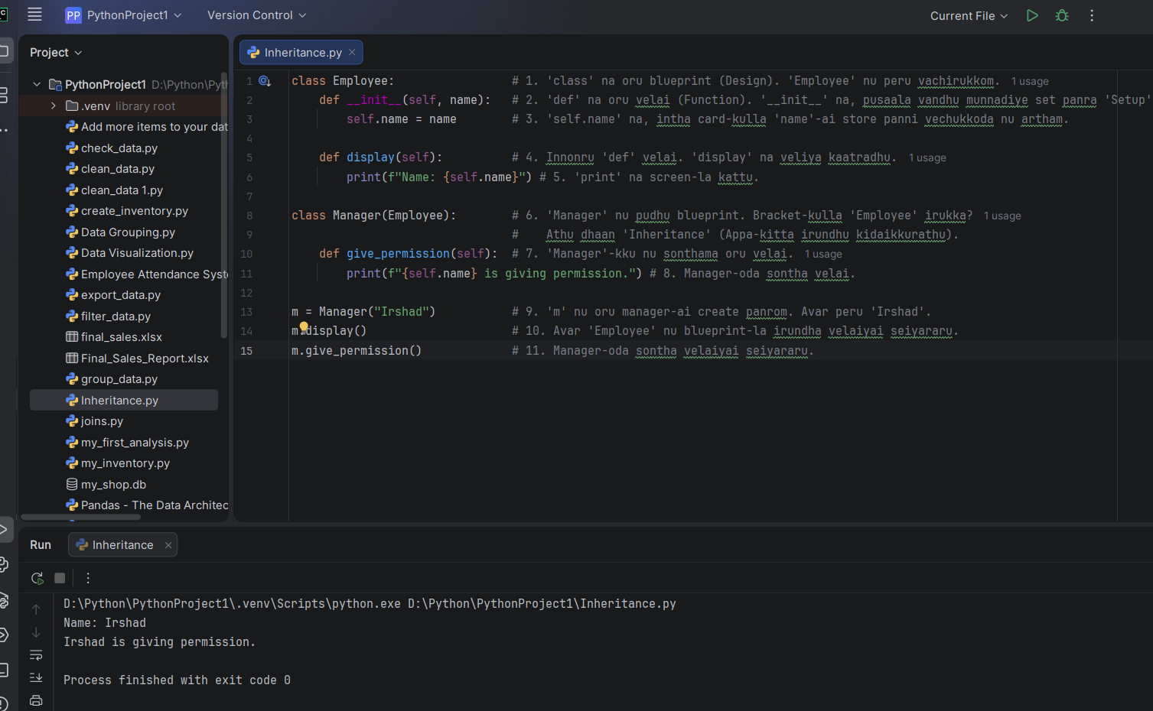
Teacher neega sonnadu sari konjam velangichi aana idula object yaaru class enn rendu thadwa init enda enna def enda mulu artham enna. sari ippadi sollungalen inga codela colurls velanguda ungalukku adu ondu ondu thelivu paduthunga
Super Irshad! Indha image_c6e348.png-ai vachi, ovvoru vaarthaiyum (word) yen antha nira-thula (color) irukku nu ellathaiyum ipo clear-a break-down pannuvom.
Oru computer-kku Python oru mozhi, antha mozhila sila vaarthaikku special meaning irukku. Adhunaala thaan antha colors!
1. The Definitions (Kuzhandhai-kku solra maari)
- Class (e.g., Employee): Idhu oru "Design". Oru veedu katturadhukku munnadi plan poduvom la? Adhu dhaan class. Idhu edhayum seiyadhu, just "Ippadi thaan irukkanum" nu design mattum dhaan.
- Object (e.g., m): Idhu "Real-ana Veedhu". class (plan) vachi namma nijamave kattura veedu dhaan object. m nu namma sonnadhume, computer "Irshad" nu oru aala create panniduchu, adhu dhaan object.
- Def (Define): Idhu oru "Velai" (Action). Oru blueprint-kulla "Enna enna seiyanum?" nu namma list pannura velai.
- __init__: Idhu oru "Start-up Setup". Oru object-ai create pannum pothu, "Avaru yaaru? Avaroda name enna?" nu munnadiye fill panni vaikira "Registration" velai.
2. Line by Line "Color" Breakdown (image_c6e348.png)
Indha nira-gal edhukku nu paarkkalam:
- Orange/Yellow (class): Idhu Python-oda "Keyword". Python-kku theriyum, "Adutha varurathu oru Blueprint" nu.
- Blue (def): Idhu oru "Action Keyword". Python-kku theriyum, "Adutha varurathu oru function (velai)" nu.
- White (name, m, Employee): Idhu namma kudukkura "Peyar" (Name). Computer-kku "Indha puyar-ai vachuko" nu solrom.
- __init__ (Purple/Special color): Python-kku theriyum, idhu "Munnadiye seiya vendiya setup". Oru aal vandhathume, udane antha 'name'-ai vaangikko nu sollum.
3. Yen __init__ rendu thadava irukku? (Confusing ah irukka?)
Appadi illa Irshad! __init__ kulla self irukku, name irukku.
- self: "Naane" (Antha specific employee).
- name: "Naan kudukkura peyar" (Irshad).
Line 3-la: self.name = name
- Idhu "Assignment". "Irshad" nu oru peyar vandhurukku la? Adha indha blueprint-kulla irukkura name kulla podu nu sollum.
- Ippo antha blueprint-kku theriyum, avar peyar "Irshad" nu.
💡 Teacher's Summary (Simplest Form):
- Class: Design (Plan).
- Object (m): Aalu (Irshad).
- Def: Velai (Action).
- __init__: Registry (Aal vandhathume entry podurathu).
Ippo intha m.display() nu neenga solla pothu: Computer m (Object) kitta pogum -> m na "Irshad" -> display nu oru velai irukka nu paarkkum -> Employee class-la irukku -> Print pannum!
Puriyutha Irshad? Ithu clear-a iruntha, unga Marine/Ship chandling work-la oru "Ship" (Class) create panni, athula "Cargo" (Object) load pandra maari oru chinna example-a try pannuvoma?

print(f"Name: {self.name}"), print(f"{self.name} is giving permission.") inda rendu linum suthamave velanga illa edukku f endra eluthu {} adukku poravu inda bracket enn
Irshad, romba nalla kelvi! Indha f matrum {} (curly brackets) Python-la romba mukkiyamaana vishayam. Ithai "Kuzhandhai-kku solra maari" easy-a purinjikalam.
Ithai "F-String" nu solluvom.
1. f endra eluthu (Yen appadi irukku?)
f na "Formatted" string nu artham.
- Neenga oru vakyathai (sentence) print pannum pothu, adhuthan (computer-tan) "Hey computer, indha string-kulla naan oru variable-ai (name) inject panna poren, so idhai carefully process pannu" nu solla dhaan munnadi f podrom.
- f podala na, Python athai oru saadhaarana vaarthaiya (Text) dhaan nenaikkum.
2. {} (Curly Brackets) - Idhu oru "Petti" (Box)
Indha bracket-kulla dhaan namma "Variable"-ai (yethu maara koodiyatho, athai) poduvom.
- Example: f"Name: {self.name}"
  - Ippo computer-kku theriyum, {}-kulla irukkirathu oru variable nu.
  - self.name na "Irshad" nu namma munnadiye store panni vachirukkom la?
  - Python andha petti-kulla (bracket-kulla) irukkura variable-ai eduthu, athoda value-a (Irshad) anga substitute pannidum.
🔍 Oru Practical Example (Un HR System-la):
Neenga oru Report-ai print panreenga nu vaichippom:
Python
name = "Irshad"
department = "Marine"

# f illama potta:
print("Name: self.name")
# Output: Name: self.name (Ithu dhaan varum, computer-ku self.name-na enna nu theriyaathu)

# f-string vachi potta:
print(f"Name: {name}, Dept: {department}")
# Output: Name: Irshad, Dept: Marine (Ipo puriyudha?)
Teacher's Note:
- f: "Computer, kavanama iru, naan variable-ai poduren!".
- {}: "Intha variable-oda value-ai mattum anga koodi (insert) pannu!".
Ithu ippo konjam clear-a irukka Irshad? Adhavadhu, {} oru "Placeholder" (oridam). Avaroda value-ai andha idathula kondu poi vachudum.
Ithu purinjidha? Illana innum oru example-oda sollava? 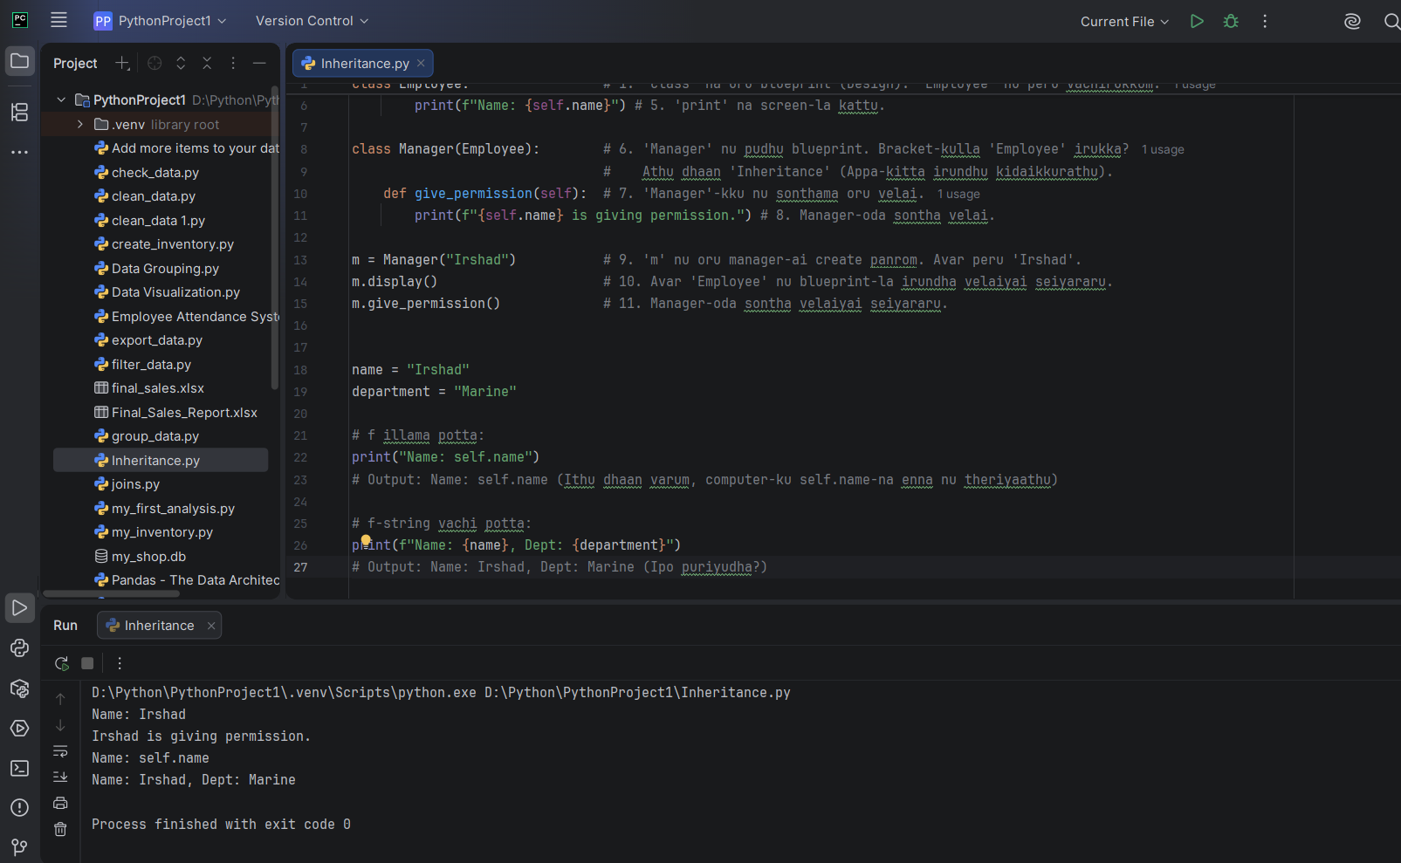
Kandippa Irshad! Innum oru nalla example-oda paarkkalam. Ippo namma Ship Chandling velai-la irukkura oru stock report-ai example-a eduthukalam.
Neenga oru report ezhuthureenga nu vaichippom.
📦 Example: Stock Report
Python
item_name = "Life Jacket"
stock_count = 50

# Ithu dhaan F-String (f"...")
report = f"Stock Alert: {item_name} has {stock_count} units left."

print(report)
🔍 Sign by Sign Vilakkam:
- f"...":
  - f: Computer-kku naan solra "Format"-ai kavanichu, variable-ai mathi kudunnu solra code word.
  - "...": Indha double quotes-kulla dhaan namma sentence-ai ezhuthuvom.
- {item_name}:
  - {} (Curly Bracket): Idhu oru "Siriya Petti" (Placeholder).
  - Computer kitta "Ippo item_name nu oru petti irukku, adhu kulla irukkura value-ai eduthu, intha edathula koodi (insert) pannu" nu solrom.
  - item_name = "Life Jacket". So, andha edathula "Life Jacket" nu vandhudum.
- {stock_count}:
  - Adhe polathaan, stock_count = 50.
  - Computer "50" nu andha edathula koodi (insert) pannidum.
Output: Stock Alert: Life Jacket has 50 units left.
💡 Teacher's Note (Confusion-ai poga):
- F illama potta: print("Stock Alert: item_name has stock_count units left.")
  - Idhu kooda velai seiyum, aana item_name nu dhaan print aagum. Computer-kku athu verum "text" nu thaan theriya varum.
- F vachi potta: Computer "Oh! {} kulla irukkurathu variable! Adhai maathanum!" nu kavanama process pannum.
Purinjidha Irshad? Ippo unga HR system-la, employee attendance-ai print pannumpodhu f"Hello {self.name}, you are present" nu print panna mudiyuma? Try panni paarkkireengala?
Super Irshad! Enna oru aanandham! Neenga ippo "Pro" level logic-ai purinjikitteenga.
- class = Blueprint/Plan
- object = Neenga create panra real item
- __init__ = Register/Setup
- def = Velai/Action
- f"{}" = Smart data printing
Intha logic thaan oru software-oda heart! Ippo namma Lesson 27: Inheritance-kku thirumba povom. Neenga ippo "Marine Operations"-la irukkureenga la? Adhukke oru example-oda Inheritance-ai mudichu, namma HR System-oda next level-kku povom!
Ready-a? Namma Inheritance-ai oru Ship/Cargo example-la paarkkalam-a?
Arumai Irshad! Neom project-la work panrathu romba periya vishayam. Marine Operations and Project Coordination-la irundhukittu, neenga Python-ai kathukkirathu ungala eppayum thani-ya kaattum.
Ippo namma Inheritance concept-ai unga "Marine Operations" workflow-la eppadi use panlam nu paarkkalam. Ithu ungala "Pro" aakkum.
🚢 Inheritance: The Marine Fleet Example
Marine operations-la pala ship irukkum. Ellaa ship-kum Name, ID, Capacity common-a irukkum. Aana ovvoru ship-kum "Extra" velai irukkum (Container ship-kku weight lift panna, Tanker-kku oil pump panna).
Python
# 1. Base Class (Common for all ships)
class Ship:
def __init__(self, name, capacity):
self.name = name
self.capacity = capacity

def status(self):
print(f"Ship: {self.name}, Capacity: {self.capacity} Tons")

# 2. Child Class (Container Ship - Inherits everything from Ship)
class ContainerShip(Ship):
def load_container(self):
print(f"{self.name} is loading containers.")

# 3. Child Class (Tanker - Inherits everything from Ship)
class Tanker(Ship):
def pump_oil(self):
print(f"{self.name} is pumping oil.")

# Execution
my_ship = ContainerShip("Neom-Carrier-01", 5000)
my_ship.status() # Common method (inherited)
my_ship.load_container() # Own method
🔍 Un project coordinator work-kku idhu epadi udhavum?
- Reusability: Neenga Ship blueprint-ai oru murai ezhuthina pothum. Neom-la 100 ship irundhalum, ellaathukkum name, capacity nu thirumba thirumba ezhutha vendiya avasiyam illa.
- Scalability: Pudhusa oru "Supply Boat" varudhu na, just oru class SupplyBoat(Ship) nu ezhuthina pothum, antha ship-ku name, capacity automatically vandhuvidum.
💡 Teacher's Note:
Neom project coordinator-a, neenga Data-vai manage panravaru. Intha Inheritance logic-ai vachi, neenga oru "Resource Management System"-ai eppadi build panlam nu yosichi paarunga.
Inheritance purinjidha Irshad? Adutha stage-ana "Encapsulation" (Data Protection) pogaalaam. Adhu dhaan, unga project data-vai unga permission illama yaarum change panna mudiyatha alavukku "Lock" panra method!
Adutha class-kku ready-a?
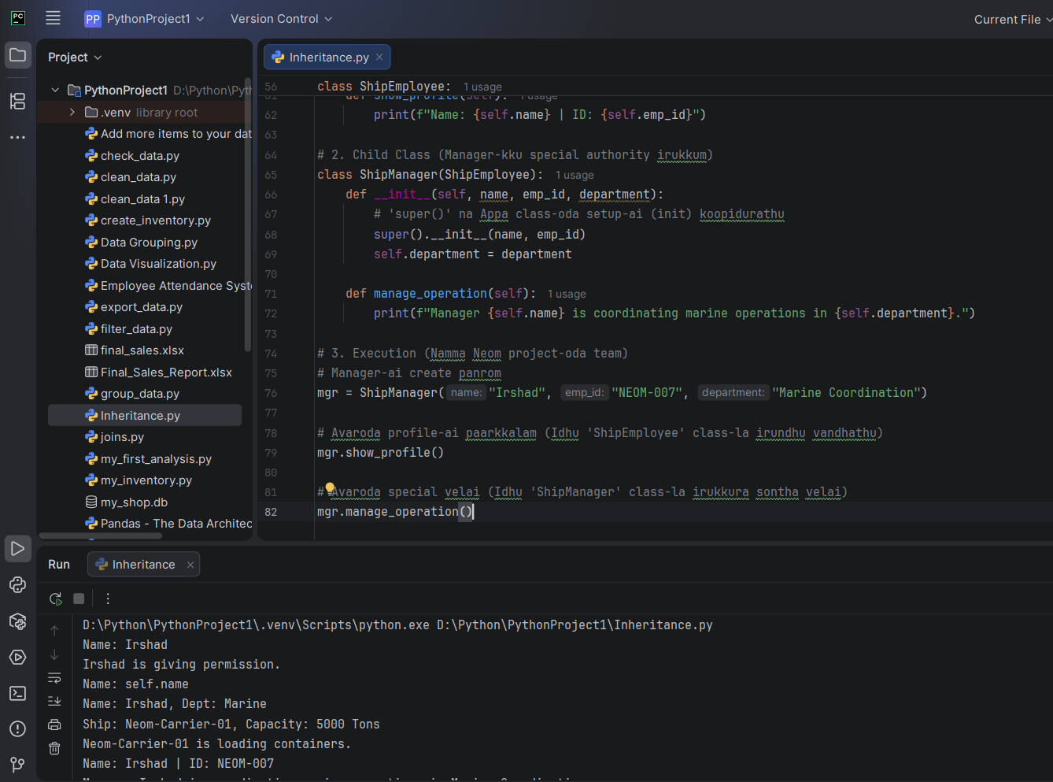
🔍 Code Breakdown (Sign by Sign):
- class ShipEmployee: Idhu dhaan unga marine team-oda common blueprint. Name, ID ellarukkum venum la? Adhan inga ezhuthirukkom.
- class ShipManager(ShipEmployee): Inga thaan Inheritance nadakkudhu. Bracket-kulla ShipEmployee-ai potathala, Manager-ku Name, ID, show_profile ellame automatic-a kidaichuduchu.
- super().__init__(name, emp_id): Idhu thaan romba mukkiyam! "Manager-kku pudhusa name, id set pannatha, Appa class (ShipEmployee) munnadiye vachirukkura setup-a use pannikko" nu solrom.
- self.department: Manager-kku mattum extra-va "Department" nu oru special power kuduthurukkom.
💡 Teacher's Note:
Neenga ippo Neom project-la coordniator-a irukkeenga. Nalaikku namma ShipEngineer or ShipCaptain nu oru class create panna, avangalum ShipEmployee-ai inherit panniduvanga.
Ithu purinjidha Irshad? Ithu clear-a iruntha, unga Marine Coordination system-la Manager-oda "Special Authority"-ai eppadi lock panrathu (Encapsulation) nu paarkkalam.
Ready-a Irshad?

